PROJECT – HIGH LEVEL DESIGN

On

IaC Provisioning for Finance System

  - Course Name: DevOps Foundation

Institution Name: Medicaps University – Datagami Skill Based Course

Student Name(s) & Enrolment Number(s):
Sr no | Student Name | Enrolment Number
01 | AYUSH SAHU | EN22IT301027
02 | MAHIMA SANTORE | EN22IT301053
03 | HITAKSHI SONI | EN22IT301039
04 | BHUMIKA ATALSIYA | EN24CA5030035
05 | HARSH PATEL | EN24CA5030059

Group Name: Group 05D12
Project Number: DO-43
Industry Mentor Name: Mr. Vaibhav sir
University Mentor Name: Akshay Saxena sir
Academic Year: 2025 – 2026

Table of Contents
- Introduction.
  - Scope of the document.
  - Intended Audience
  - System overview.
- System Design.
  - Application Design
  - Process Flow.
  - Information Flow.
  - Components Design
  - Key Design Considerations
  - API Catalogue.
- Data Design.
  - Data Model
  - Data Access Mechanism
  - Data Retention Policies
  - Data Migration
- Interfaces
- State and Session Management
- Caching
- Non-Functional Requirements
  - Security Aspects
  - Performance Aspects
- References

1. INTRODUCTION
1.1 Scope of the Document
This High-Level Design (HLD) document serves as the formal architectural blueprint for the IaC Provisioning for Finance System (Project DO-43). The primary scope is to define a robust strategy for automating cloud infrastructure, establishing seamless interaction between DevOps toolchains, and ensuring a secure deployment framework. It focuses on bridging the gap between traditional manual configuration and modern automated orchestration to maintain high availability and environmental parity.

1.2 Intended Audience
Project Evaluators & Technical Faculty: To verify the implementation of DevOps methodologies like CI/CD and Infrastructure as Code (IaC).

System Architects & DevOps Engineers: To understand the structural dependencies between Terraform scripts and Dockerized microservices.

Developers: To gain a technical overview of the environment in which the finance application will be executed.

1.3 System Overview
The IaC Provisioning for Finance System is an advanced automation platform designed to eliminate the challenges of manual environment setup. By treating infrastructure as software, the system provides a 100% Repeatable and Scalable Setup. Key features include automated AWS resource creation via Terraform, deep configuration management via Ansible, and application isolation using Docker containers.

2. SYSTEM DESIGN
2.1 Application Design
The application adopts a decoupled, highly available three-tier architecture:
Presentation Layer: A dynamic web dashboard developed using HTML5, CSS3, and JavaScript, optimized for professional financial data visualization.
Business Logic Layer: Powered by Python (Django) and Gunicorn (WSGI HTTP Server).
Infrastructure Layer: The entire application stack is containerized using Docker and orchestrated on AWS EC2 instances, ensuring zero environmental drift across different machines.

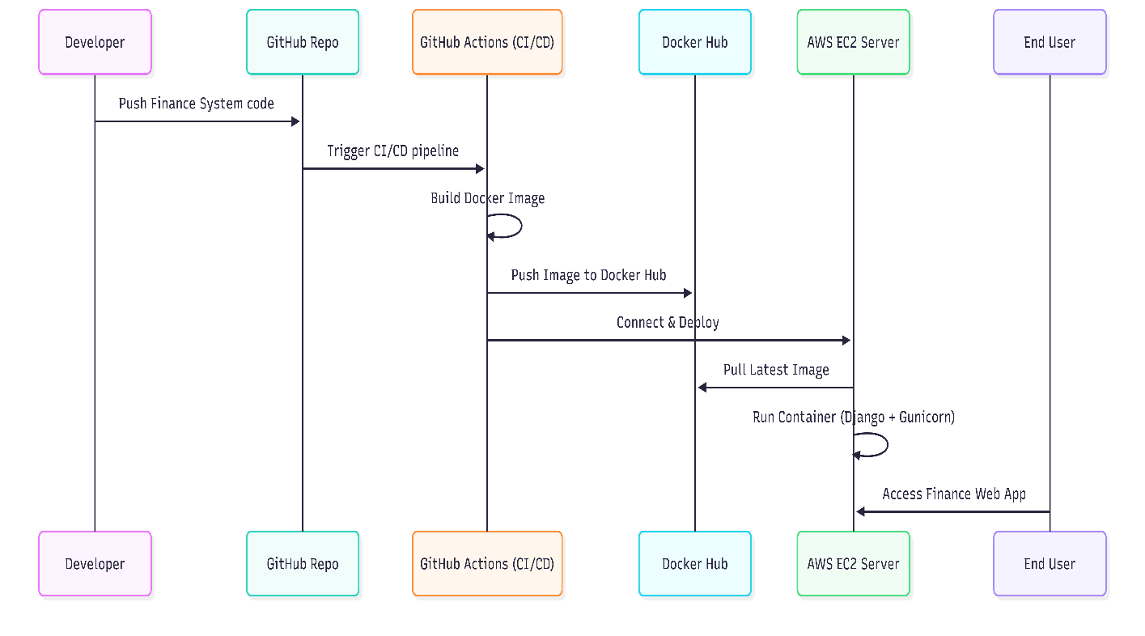

2.2 Process Flow
The system follows a strictly automated CI/CD operational sequence:
Source Code Management: The developer commits and pushes the updated source code to the GitHub repository.
Orchestration Trigger: GitHub Actions detects the push and initiates the pipeline for building the Docker image and validating infrastructure scripts.
Cloud Provisioning: Terraform automatically creates the required VPC, Subnets, Security Groups, and EC2 instances on AWS in a declarative manner.
Deployment: Ansible prepares the server environment, and Docker pulls the latest image to run the live finance application container.

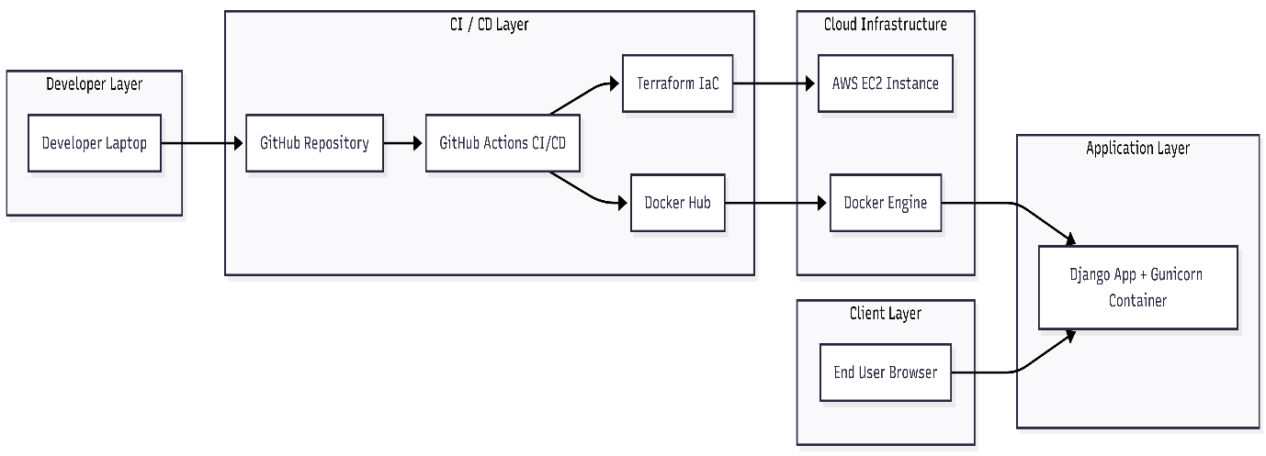

2.3 Information Flow
Input Phase: Users interact with the dashboard to submit financial queries via secure RESTful APIs.
Logic Phase: The backend engine processes the business logic using Django.
Output Phase: Processed results are fetched from the database and rendered back to the user interface in near real-time.

2.4 Components Design
VCS Module: GitHub serves as the central hub for version control and automated pipeline triggers.
IaC Engine: Terraform manages the entire lifecycle of cloud infrastructure using state files to maintain consistency.
Configuration Module: Ansible automates software installation and security hardening on the provisioned AWS servers.
Containerization: Docker ensures the application and its dependencies are bundled into a portable and secure runtime environment.

2.5 Key Design Considerations
Scalability: The architecture supports horizontal scaling of Docker containers to manage traffic spikes during peak financial cycles.
Security & Isolation: Implementation of JWT (JSON Web Tokens) for stateless authentication and AWS Security Groups for granular network isolation.

2.6 API Catalogue
Endpoint Method Description
/calculate POST Main logic endpoint for executing core financial processing using NumPy.
/health GET Diagnostic endpoint to monitor deployment status and container uptime.
/deploy POST Internal endpoint to initiate the automated IaC provisioning workflow.

3. DATA DESIGN
3.1 Data Model: The database implements a relational model with strict 3NF normalization to ensure data integrity. Entities include User, Query, Law (IPC/CrPC), and ChatResponse.

3.2 Data Access: Secure data retrieval is managed via Django ORM, ensuring all transactions are ACID compliant and protected from SQL injection.

3.3 Data Retention: Financial audit trails and transaction logs are maintained in persistent AWS EBS (Elastic Block Store) volumes for long-term auditing and recovery.

3.4 Data Migration: Automated migration scripts are integrated into the CI/CD pipeline to ensure schema consistency across all deployment stages.

4. INTERFACES
User Interface: A browser-based responsive web dashboard designed for seamless user interaction and financial reporting.

System Interface: Automated cloud orchestration through AWS APIs and container image management via Docker Hub.

5. STATE AND SESSION MANAGEMENT
Authentication: JWT (JSON Web Tokens) are utilized to manage stateless user sessions. This allows the system to scale horizontally across multiple instances without the need for session synchronization between servers.

6. CACHING
Performance Optimization: The system implements a caching layer for frequently accessed financial data and NumPy calculation results to minimize database hits and reduce overall response latency.

7. NON-FUNCTIONAL REQUIREMENTS
7.1 Security Aspects
Infrastructure Security: Implementation of AWS IAM roles, VPC isolation, and strictly defined Security Group rules.
Data Security: Secure handling of sensitive environment variables and API keys using GitHub Secrets and advanced password hashing for user accounts.

7.2 Performance Aspects
Computational Speed: Leveraging the mathematical efficiency of NumPy for near real-time financial analysis.
Resource Orchestration: Automated server-side management ensures that cloud resources are utilized efficiently, optimizing operational costs.

8. REFERENCES
Datagami Project Guidelines and Evaluation Framework.
Official Technical Documentation for Terraform, Docker, Ansible, and AWS Cloud Service

